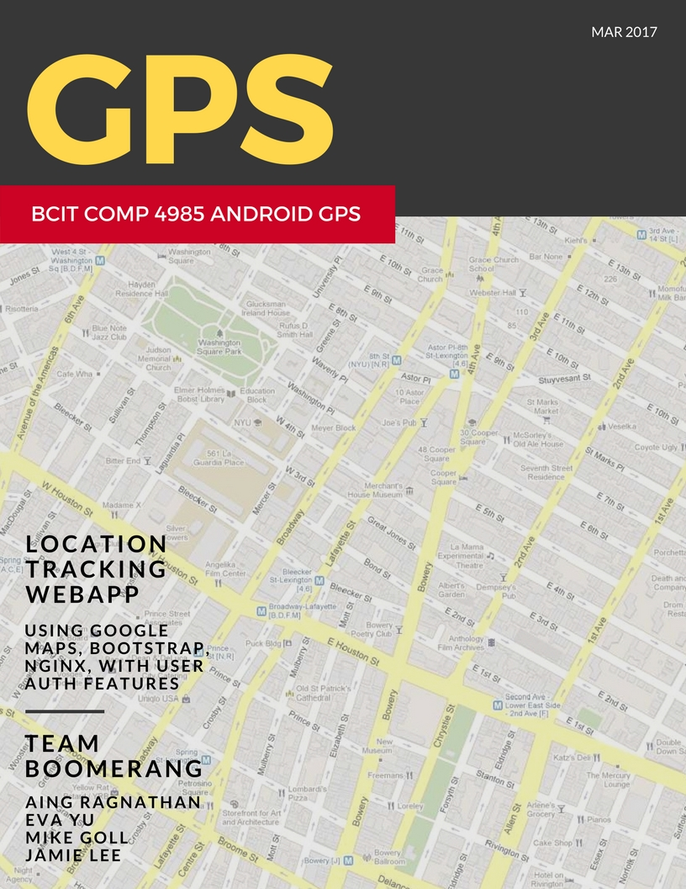

[Document title]

[Document subtitle]

[School]

[Course title]

COMP4985 A3 Test Document

# Android GPS WebApp Program

## Android GPS Client Tests

|  |  |  |  |  |
| --- | --- | --- | --- | --- |
| **Test** | **Test Steps** | **Acceptance Criteria** | **P / F** | **Description** |
| 1 | Enter no username, timer interval 1 minute  click connect | GPS data captured and stored as anonymous every minute | P | Anonymous entry submitted to database every minute. |
| 2 | Enter a username, timer interval 1 minute  click connect | GPS data captured and stored as username input every minute | P | Submitted coordinates every minute. |
| 3 | Enter another ip, with timer interval at 1  click connect | Cannot connect | P | Database doesn’t update |
| 4 | Enter another port, with the previous set up | Cannot connect | P | Database doesn’t update |
| 5 | Prompt for permission during startup | Popup box asking to allow device location | P | User is prompted at start up |

## WebApp Tests

|  |  |  |  |  |
| --- | --- | --- | --- | --- |
| **Test** | **Test Steps** | **Acceptance Criteria** | **P / F** | **Description** |
| 1 | Open a browser, cache cleared to go to 159.203.12.137 | User is prompted to enter username and password | P | The webpage opened up to the sign in modal. |
| 2 | Enter valid username only  Click Enter | User receives wrong password / user warning | P | The modal refreshed itself and prompted for another username and password. |
| 3 | Enter valid password only  Click Enter | User receives wrong password / user warning | P | The modal refreshed itself and prompted for the username and password again. |
| 4 | Enter invalid Username and Password Click Enter | User receives wrong password / user warning | P | The modal rejected entrance, refreshed itself and prompted for the username and password again. |
| 5 | Enter valid Username / password | User enters the website, sees admin page | P | The home page loaded and displayed. |
| 6 | Click on the team logo | Page refreshes | P | The page refreshed itself and redisplayed the home page. |
| 7 | Click on the **Map** on side menu | Page loads map | P | The map page loaded and displayed the map with some points. |
| 8 | Enter new data | Map data reloads | P | The map data reloaded and displayed the new information. |

## GPS Server Tests

|  |  |  |  |  |
| --- | --- | --- | --- | --- |
| **Test** | **Test Steps** | **Acceptance Criteria** | **P / F** | **Description** |
| 1 | Send invalid data | Data is not written to DB, error is logged |  |  |
| 2 | Connect 1 client | Client data gets handled and written to DB |  |  |
| 3 | Connect 4 Clients | All client data gets handled and written to DB |  |  |
| 4 |  |  |  |  |

## Database Tests

|  |  |  |  |  |
| --- | --- | --- | --- | --- |
| **Test** | **Test Steps** | **Acceptance Criteria** | **P / F** | **Description** |
| 1 | Send data missing username | Data is set with username = anonymous |  |  |
| 2 | Send data missing datetime | Data is set with time = time of entry |  |  |
| 3 | Send data without ipaddr | Data is set with ip = 0.0.0.0 |  |  |
| 4 | Send data without MAC | Data is not set |  |  |
| 5 | Send data without longitude | Data is not set |  |  |
| 6 | Send data without latitude | Data is not set |  |  |
| 7 | Send data with invalid longitude | Data is not set |  |  |
| 8 | Send data all values filled and correct | Data is set as the values specified |  |  |

# Screenshots

## Android GPS Client Tests

|  |  |  |
| --- | --- | --- |
| **Test** | **Test Steps** | **Screenshot** |
| 1 | Enter no username, timer interval 60  click connect |  |
| 2 | Enter a username, timer interval 60  click connect |  |
| 3 | Enter another ip, with timer interval at 1  click connect | C:\Users\Aingaran\AppData\Local\Microsoft\Windows\INetCacheContent.Word\Screenshot_20170328-013221.png |
| 4 | Enter another port, with the previous set up | C:\Users\Aingaran\AppData\Local\Microsoft\Windows\INetCacheContent.Word\Screenshot_20170328-013221.png |
| 5 | Prompt for permission during startup | C:\Users\Aingaran\AppData\Local\Microsoft\Windows\INetCacheContent.Word\Screenshot_20170327-232929.png |

## WebApp Tests

|  |  |  |
| --- | --- | --- |
| **Test** | **Test Steps** | **Screenshot** |
| 1 | Open a browser, cache cleared to go to 159.203.12.137 |  |
| 2 | Enter valid username only  Click Enter |  |
| 3 | Enter valid password only  Click Enter |  |
| 4 | Enter invalid Username and Password Click Enter |  |
| 5 | Enter valid Username / password |  |
| 6 | Click on the team logo |  |
| 7 | Click on the **Map** on side menu |  |
| 8 | Enter new data |  |

## GPS Server Tests

|  |  |  |
| --- | --- | --- |
| **Test** | **Test Steps** | **Screenshot** |
| 1 | Send invalid data |  |
| 2 | Connect 1 client |  |
| 3 | Connect 4 Clients |  |
| 4 |  |  |

## Database Tests

|  |  |  |
| --- | --- | --- |
| **Test** | **Test Steps** | **Screenshot** |
| 1 | Send data missing username |  |
| 2 | Send data missing datetime |  |
| 3 | Send data without ipaddr |  |
| 4 | Send data without MAC |  |
| 5 | Send data without longitude |  |
| 6 | Send data without latitude |  |
| 7 | Send data with invalid longitude |  |
| 8 | Send data all values filled and correct |  |